

|  |  |  |  |  |  |  |  |  |
| --- | --- | --- | --- | --- | --- | --- | --- | --- |
|  | | | | | | | | |
|  | | AI Practical File | | | | |  | |
|  |  | | | | | | |  |
|  | | | |  |  | | | |
|  | | | | ARNAVTHAKUR |  | | | |
|  | | | | 2023-24—Grade 10th |  | | | |
|  | | |  | | |  | | |

|  |  |  |  |  |  |  |  |  |
| --- | --- | --- | --- | --- | --- | --- | --- | --- |
|  |  | | |  |  | | |  |
|  | INSTRUCTIONS | | | | | | |  |
|  |  | | |  |  | | |  |
|  |  | |  | | |  | |  |
|  |  |  | Artificial Intelligence (AI) is like a smart computer brain that can learn and understand things, making it super helpful in many ways. One cool thing it does is called Computer Vision (CV), which helps computers see and recognize things, like telling if there's a cat or a dog in a picture.  Another awesome thing AI does is Natural Language Processing (NLP), which is like teaching computers to understand and talk with us in a way that feels natural | | |  |  |  |
|  | | | | |
|  |  |  |  |
|  |  |

|  |  |  |  |  |  |  |
| --- | --- | --- | --- | --- | --- | --- |
|  | |  |  |  |  | |
|  | | Part A- Basics of Python | | |  | |
|  | |  |  |  |  | |
|  | **a. Display the sum of 1st 10 natural numbers**  Code-    Output-    **b. Check whether the user is eligible to vote or not. (Input the age from user)**  *Code-*    Output-    **c. Check if the number entered by the user is positive, negative or zero**  *Code-*    *Output-* | | | | |  |
|  |
|  |
|  |
|  |  |

|  |
| --- |
|  |



|  |  |  |  |  |  |  |
| --- | --- | --- | --- | --- | --- | --- |
|  | | Part B – Data Science | | |  | |
|  | |  |  |  |  | |
|  | **1 a. Create an array using numpy**  Code-    Output-    **1 b. Add two arrays**  *Code-*    *Output-*    **1 c. Create a scatter plot for given data.  i) x = ['Ram','Shyam','Jeena','Sheena','Tam','Tom']  y = [99,86,87,88,91,86]**  *Code-*    *Output-*    **1 c. ii) Change the color of the scatterplot to green.**  *Code-*    *Output-*    **2. i) The width of the bars to 0.1**  *Code-*    *Output-*    **2. ii) Color to red**  *Code-*    *Output-*    **2. iii) Title to BAR CHART and its font size as 30 and color as yellow.**  *Code-*    *Output-*    **3. i) Change the color of the wedges to any color of your choice**  *Code-*    *Output-*    **3. ii) Give the title as ‘Name of the student’.**  *Code-*    *Output-*      *Code-*    *Output-*    **a)** **Display an image using opencv**  *Code-* | | | | |  |
|  |
|  |

|  |  |  |  |  |
| --- | --- | --- | --- | --- |
|  | Part C – Computer Vision | | |  |
|  |  |  |  |  |
|  |  |  |  |  |

*Output-*

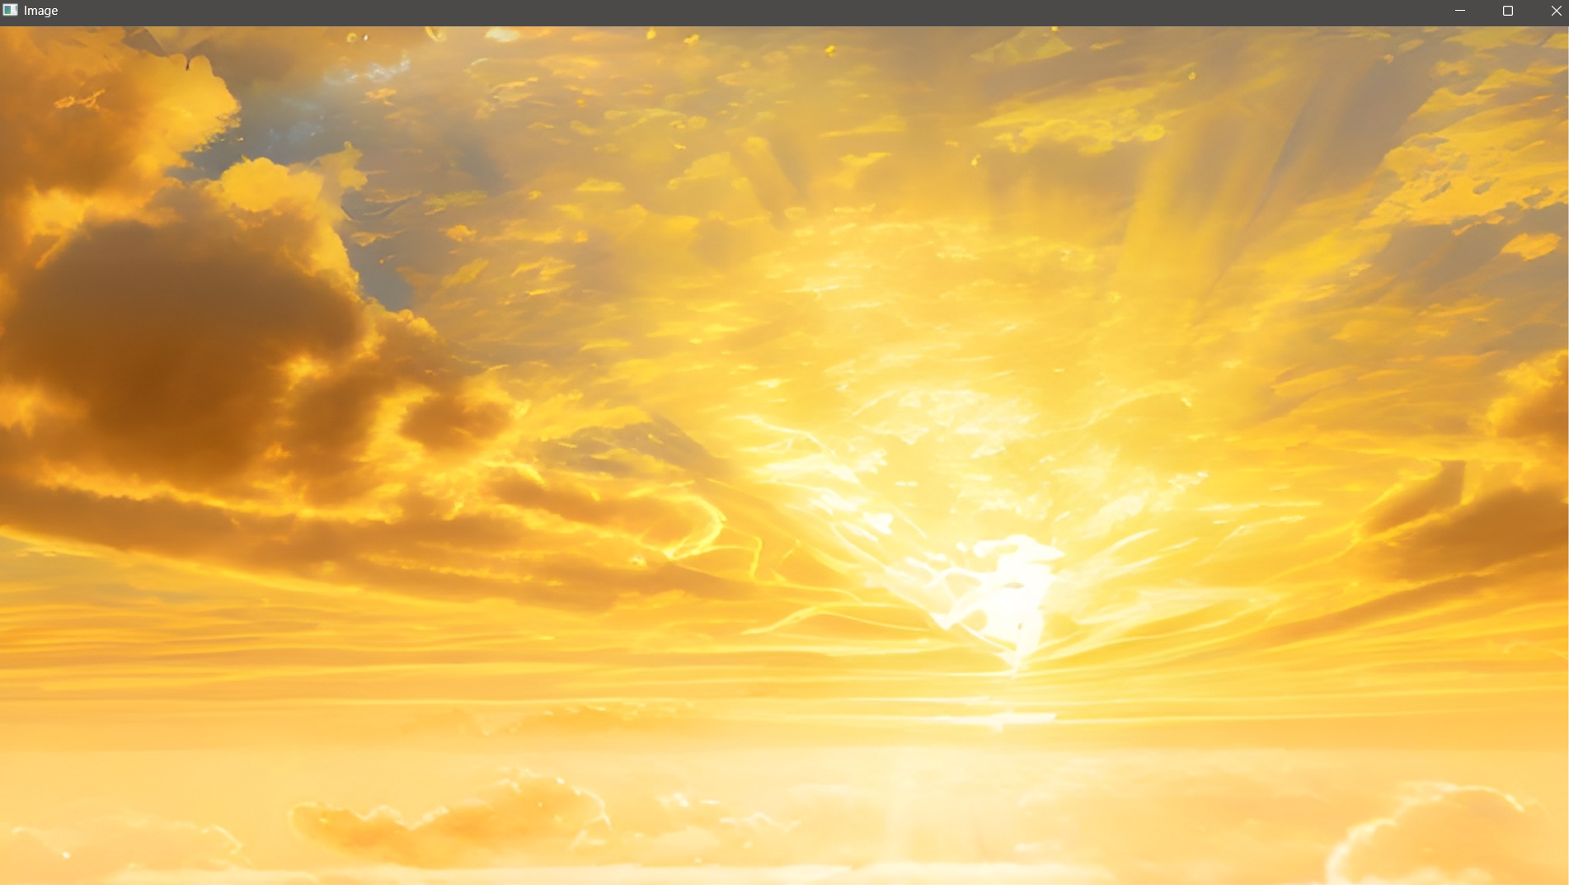

**b)** **Show an image using opencv in grey scale**

*Code-*

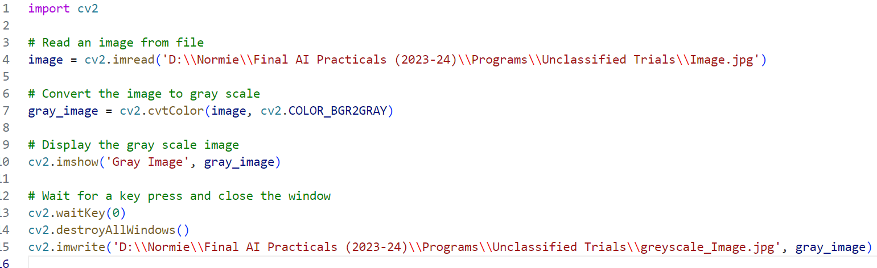

*Output-*

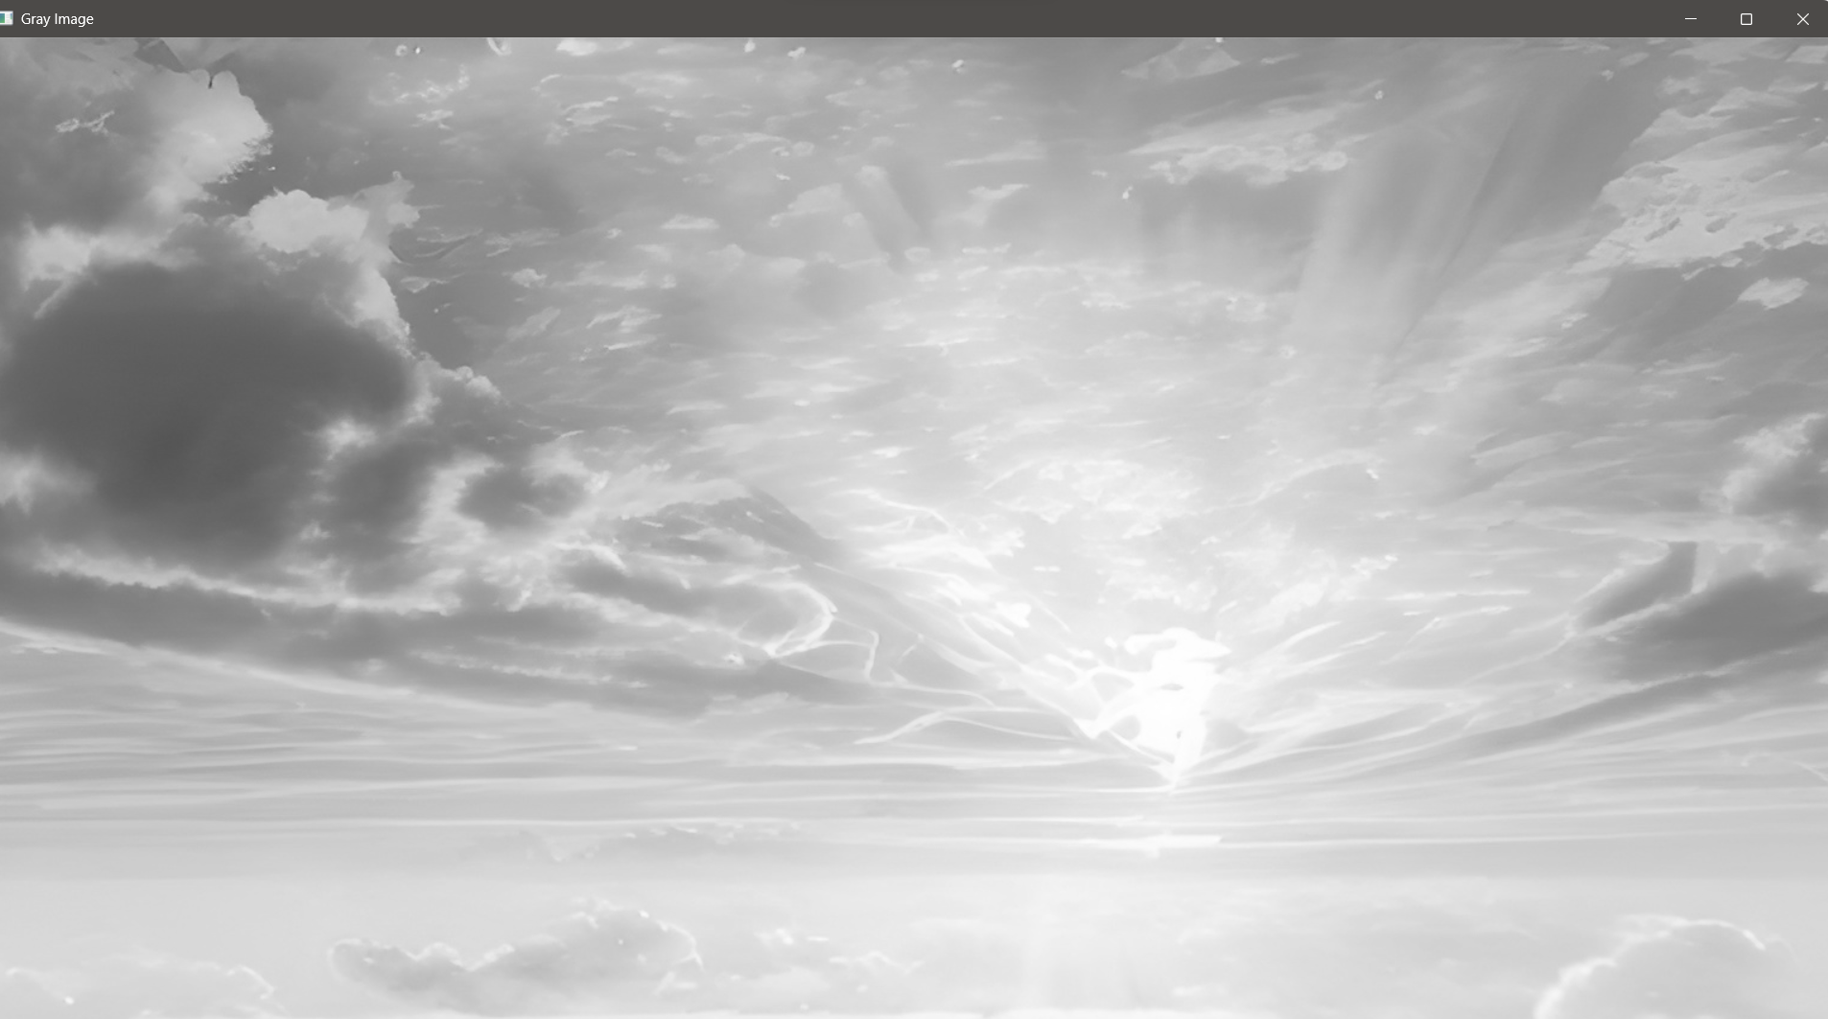

**c)** **Display the size of an image using imgshape()**

*Code-*

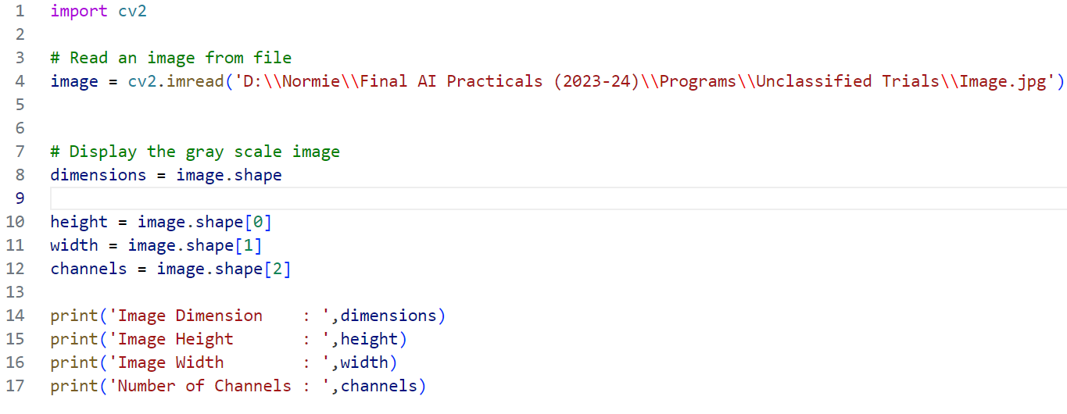

*Output-*



**d)** **Crop an image**

*Code-*

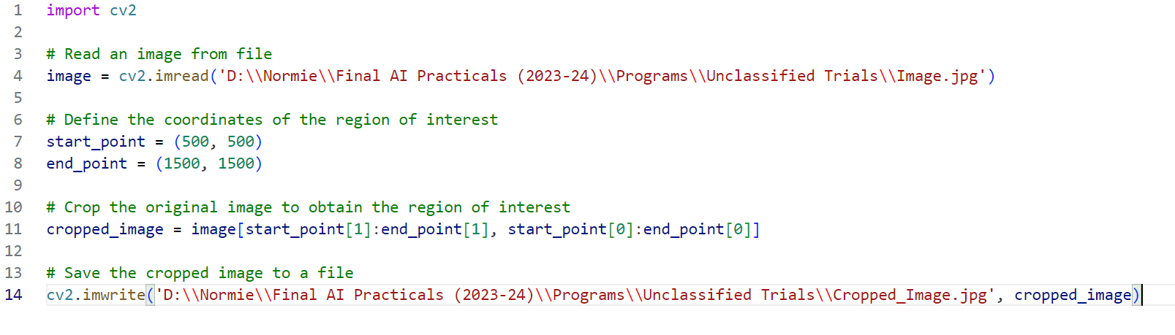

*Output-*

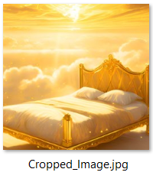

**e)** **Resizing image**

*Code-*

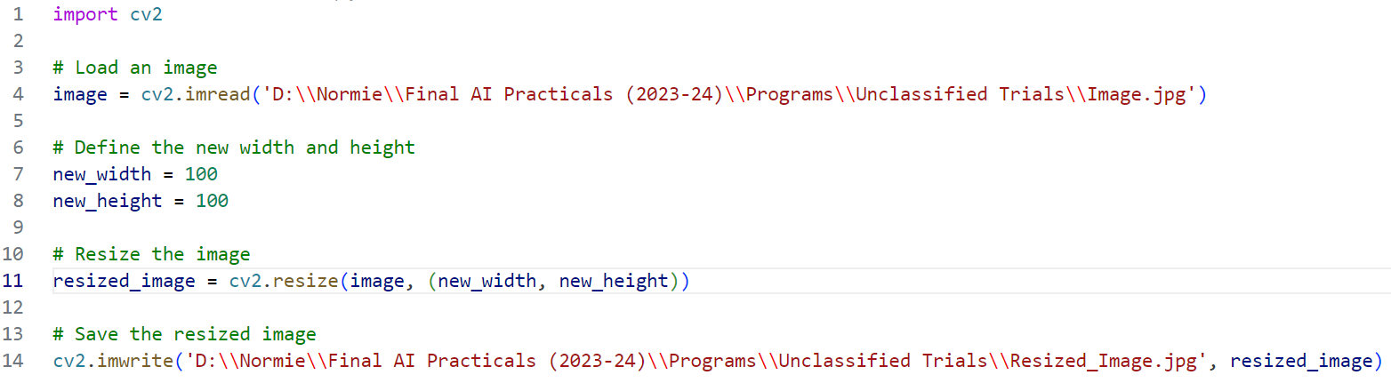

*Output-*

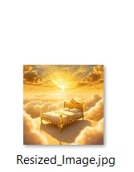

**g)** **Resizing image**

*Code-*

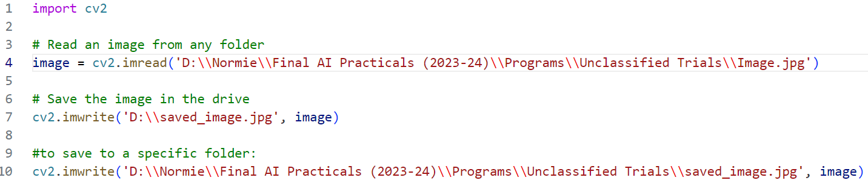

*Output-*

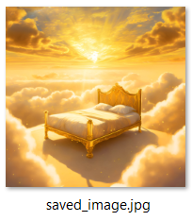

**-Project File-**



<https://github.com/arnav-notavaialable/Final-AI-Practicals-2023-24->